Another mobile phone wants to manage my MW3. What should I do?
Method 1: Provide my account to my family. And they can manage my MW3 by Tenda WiFi App.

Method 2:
Step 1: Download Tenda WiFi App by another mobile phone. Tap “Login”.

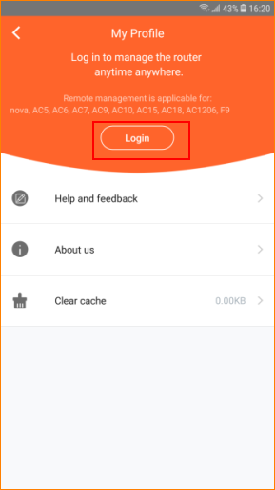

Step 2: If you configure Google Email, Facebook, Twitter in mobile phone, you can tap the logo to have Fast login.
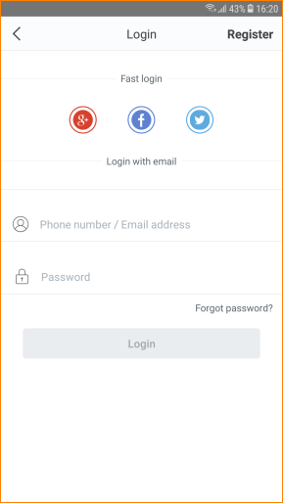

Step 3: If you want to register by email, tap “Register”, enter Email address and Password.

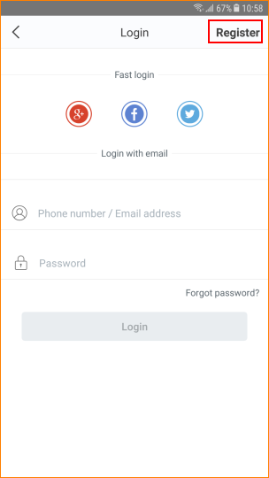
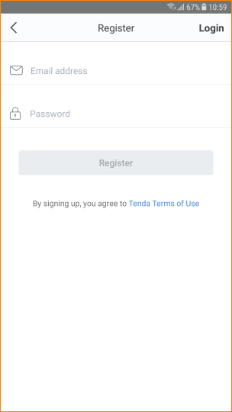

Step 4: Open my Tenda WiFi App, tap “Settings”> “Account Authorization”.
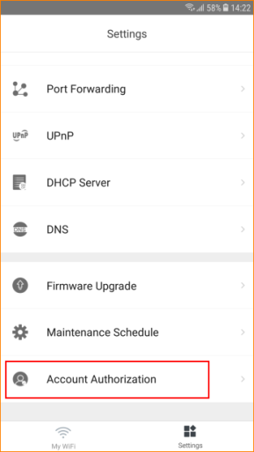

Step 3: Tap “Add an account’.
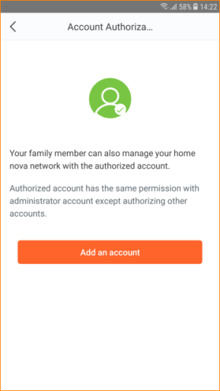

Step 4: Enter the registered account. Tap “OK”.

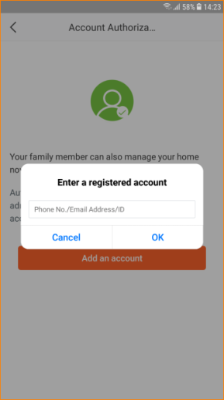
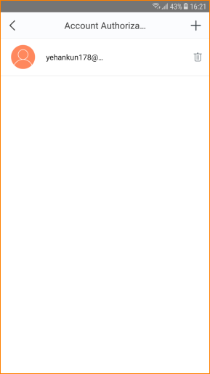

Note:
1. Totally can add no more than three accounts to manage a same MW3.
2. Authorized account does not support “Account Authorization” function.

